# R0013E Microservices - Metrics requirements 1 Clément

## Instructions:

Launch Home.php file on your web browser.

Fill in the URL in the text field. (some HTTPS URLs do not work).

Here is an example you can use: http://www.deadlinkcity.com/

It has many errors and is perfect for a test.

Click on the "Get Results" button.

The different results will be displayed, some of them may take some time and you will have to wait a little (1min 30 max).

The requests made are asynchronous, it is possible to see the javascript libraries displayed first.

## Implementation:

### CSS / HTML errors (W3C standards):

Using the open source API of W3C Markup Validation Service : <https://validator.w3.org/docs/api.html>

Writing website content in a html file.

Requesting the API with a shell execution in php and html file in parameter.

Receiving content in GNU type.

Parsing data and displaying to the webpage with ajax asynchronous request.

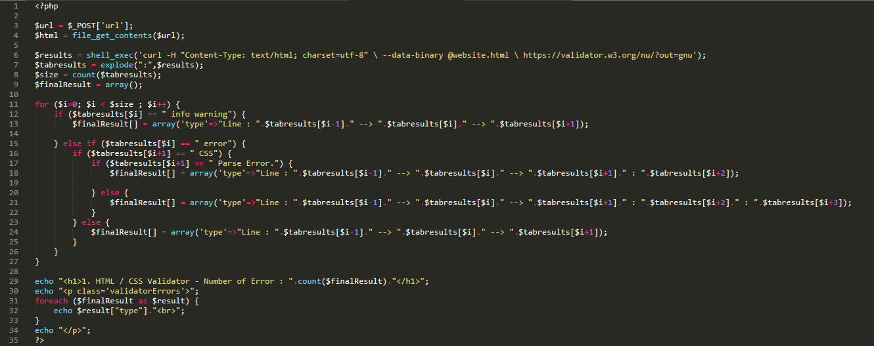

### Broken links:

Getting website content and converting in DOM object.

Parsing <a> links and getting headers for each href.

If links have HTML error Displaying <a> links to the webpage with ajax asynchronous request.

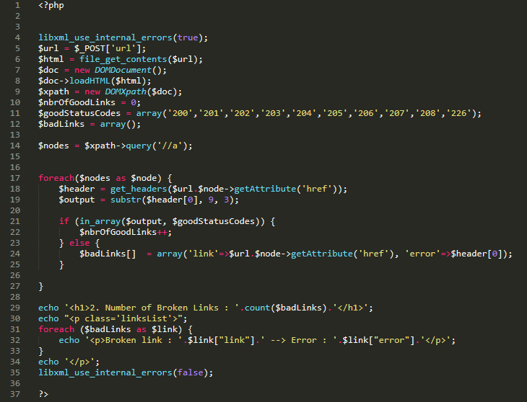

### Javascript libraries installed:

Getting website content and converting in DOM object.

Parsing <script> links and getting headers for each src.

Displaying <script> links to the webpage with ajax asynchronous request.

